CREATE JAVA APPLICATION

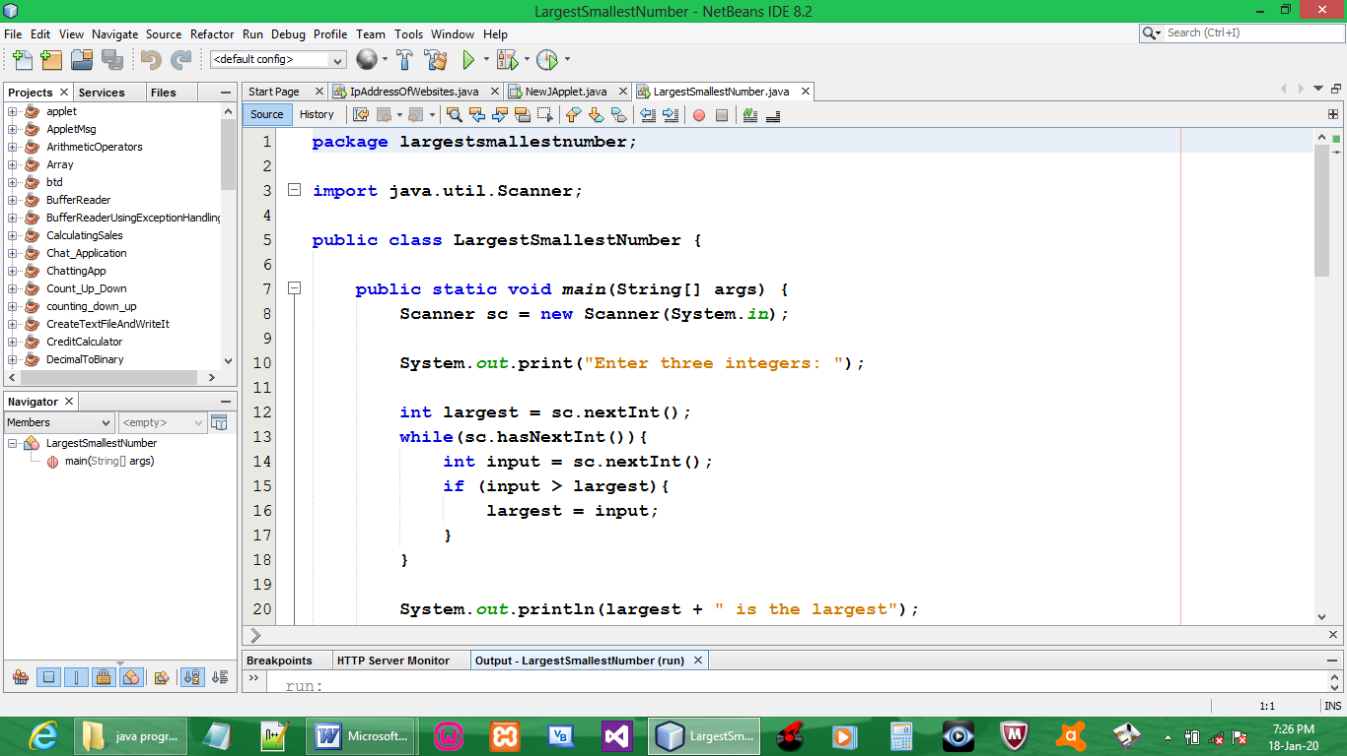

CODE:

package largestsmallestnumber;

import java.util.Scanner;

public class LargestSmallestNumber {

public static void main(String[] args) {
Scanner sc = new Scanner(System.in);

System.out.print("Enter three integers: ");

int largest = sc.nextInt();
while(sc.hasNextInt()){
int input = sc.nextInt();
if (input > largest){
largest = input;
}
}

System.out.println(largest + " is the largest");
System.out.println("\n");

Scanner we = new Scanner(System.in);

System.out.print("Enter 3 integers: ");

int smallest = we.nextInt();
while(we.hasNextInt()){
int input = we.nextInt();
if (input < smallest){
smallest = input;
}
}

System.out.println(smallest + " is the smallest");
System.out.println("\n");

int range = largest - smallest;
System.out.println(largest + " - " + smallest + " = " + range + " is the range");
}
}

OUTPUT:

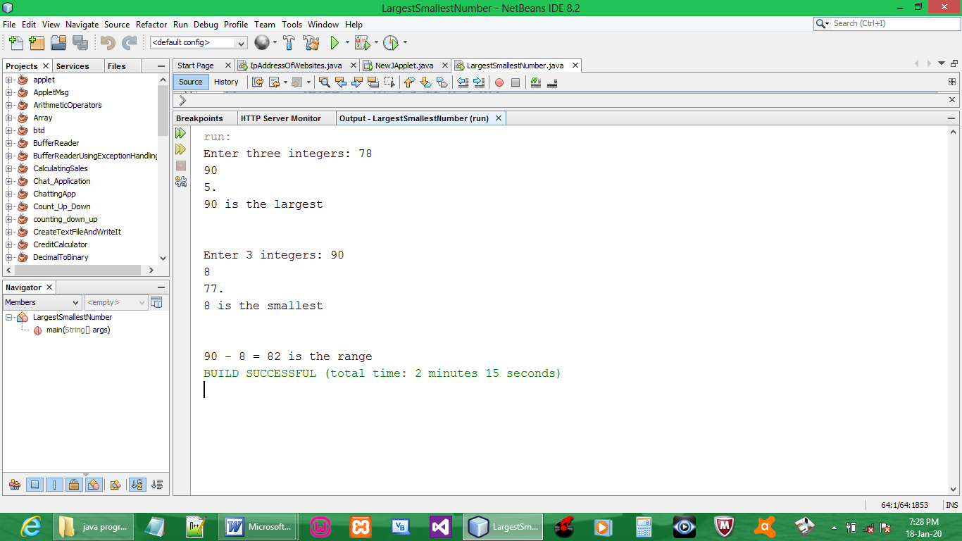

NB: when entering the 3 numbers, the third number must be stopped with an Alphabet or symbol else it loops continuously. (FIX)

Option 2

CREATE JAVA APPLICATION

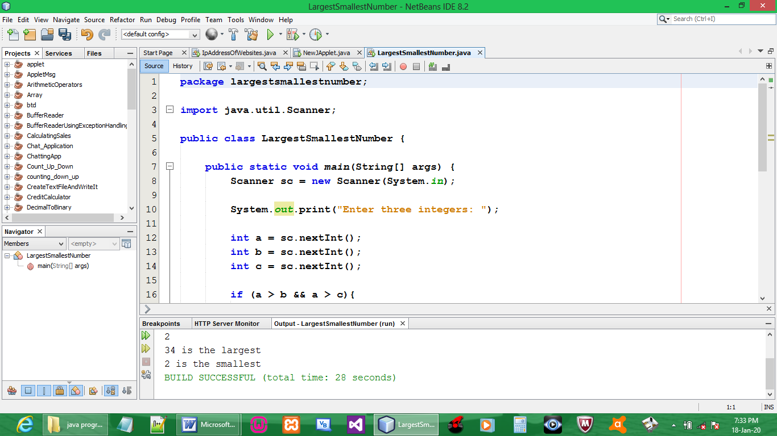

CODE:

package largestsmallestnumber;

import java.util.Scanner;

public class LargestSmallestNumber {

public static void main(String[] args) {
Scanner sc = new Scanner(System.in);

System.out.print("Enter three integers: ");

int a = sc.nextInt();
int b = sc.nextInt();
int c = sc.nextInt();

if (a > b && a > c){
System.out.println(a + " is the largest");
}else if (b > a && b > c){
System.out.println(b + " is the largest");
}else if (c > a && c > b){
System.out.println(c + " is the largest");
}
if (a < b && a < c){
System.out.println(a + " is the smallest");
}else if (b < a && b < c){
System.out.println(b + " is the smallest");
}else if (c < a && c < b){
System.out.println(c + " is the smallest");
}
}
}

OUTPUT:

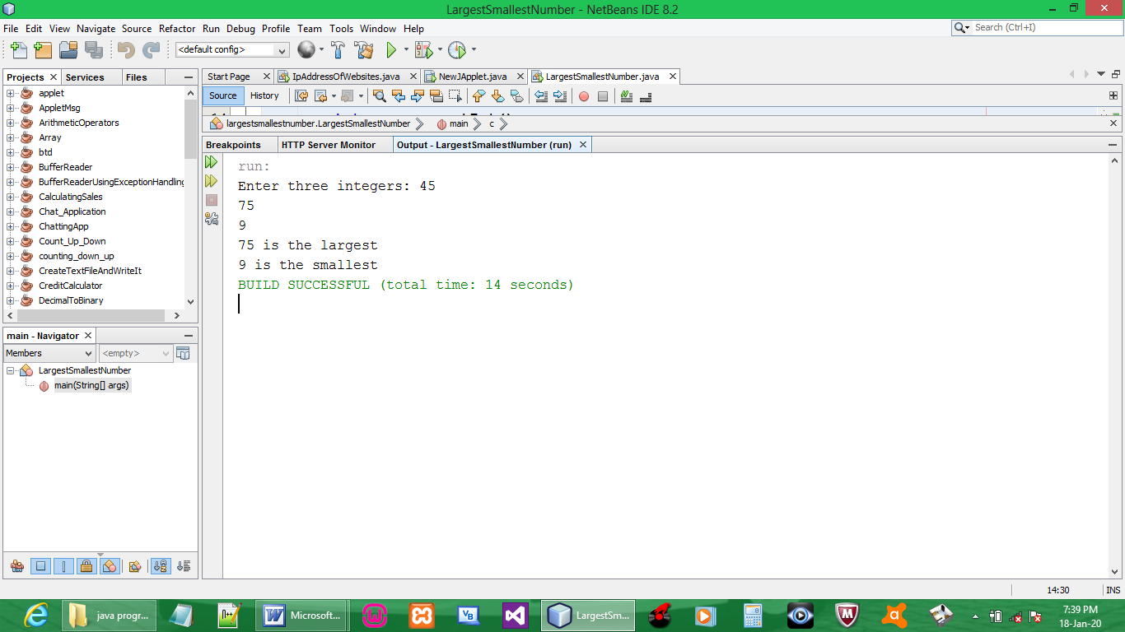

Option 3

CREATE JAVA APPLICATION

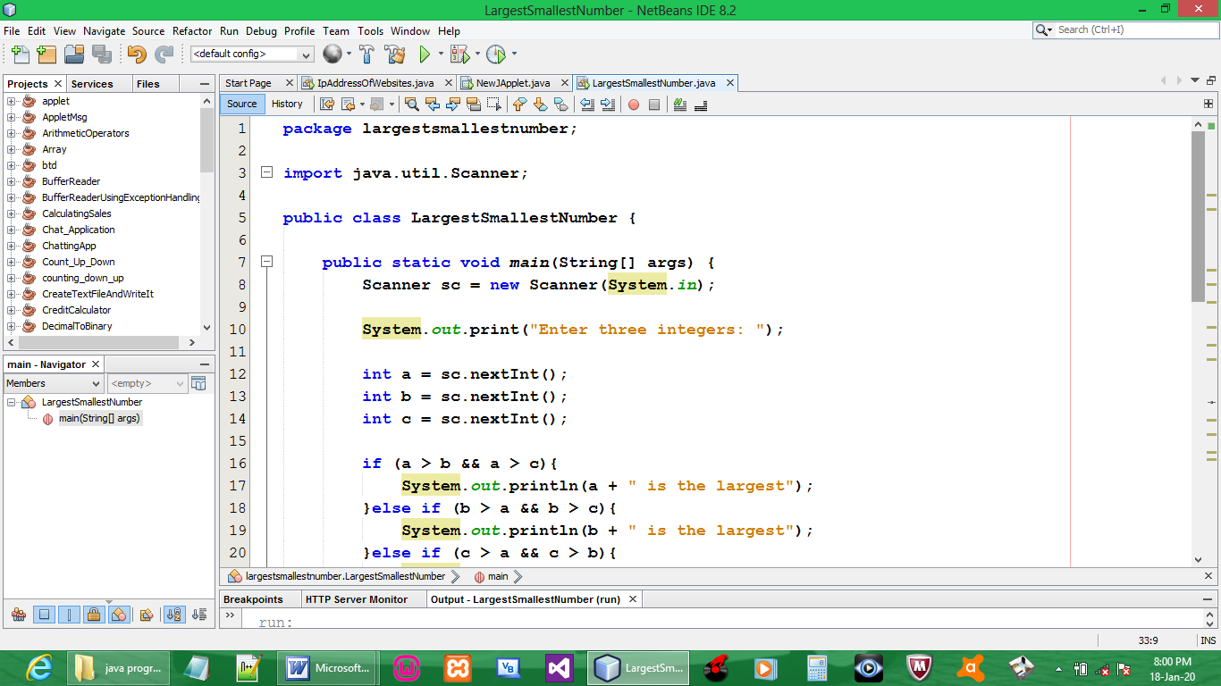

CODE:

package largestsmallestnumber;

import java.util.Scanner;

public class LargestSmallestNumber {

public static void main(String[] args) {
Scanner sc = new Scanner(System.in);

System.out.print("Enter three integers: ");

int a = sc.nextInt();
int b = sc.nextInt();
int c = sc.nextInt();

if (a > b && a > c){
System.out.println(a + " is the largest");
}else if (b > a && b > c){
System.out.println(b + " is the largest");
}else if (c > a && c > b){
System.out.println(c + " is the largest");
}

System.out.println("\n");

Scanner dc = new Scanner(System.in);

System.out.print("Enter 3 integers: ");

int d = sc.nextInt();
int e = sc.nextInt();
int f = sc.nextInt();

if (d < e && d < f){
System.out.println(d + " is the smallest");
}else if (e < d && e < f){
System.out.println(e + " is the smallest");
}else if (f < d && f < e){
System.out.println(f + " is the smallest");
}
}
}

OUTPUT:

